**Tensile Tester User Manual**

**Revisions**

|  |  |  |  |
| --- | --- | --- | --- |
| **Revision** | **Author** | **Changes** | **Date** |
| 001 | Tait Richards | Initial Release | 2021-08-23 |
| 002 | Steven Knudsen | * Updated for final configuration. No update to data logging section; no longer supported. | 2022-10-12 |

**Table of Contents**

1 Introduction 3

2 Setup 3

2.1 Raspberry Pi **Error! Bookmark not defined.**

2.1.1 Boot Process 15

2.1.2 Network Configuration 16

2.2 Tensile Test Frame **Error! Bookmark not defined.**

3 The Web-Interface **Error! Bookmark not defined.**

3.1 Access **Error! Bookmark not defined.**

3.2 Layout **Error! Bookmark not defined.**

4 Rotational Motion **Error! Bookmark not defined.**

4.1 Zeroing **Error! Bookmark not defined.**

4.2 Relative Zero **Error! Bookmark not defined.**

4.3 Motion **Error! Bookmark not defined.**

4.4 Unwinding & Homing **Error! Bookmark not defined.**

5 Tension Control **Error! Bookmark not defined.**

5.1 Zeroing **Error! Bookmark not defined.**

5.1.1 Zeroing & Calibrating the Load Cell **Error! Bookmark not defined.**

5.2 Motion **Error! Bookmark not defined.**

6 Data Logging **Error! Bookmark not defined.**

6.1 Starting and Stopping **Error! Bookmark not defined.**

6.2 File Retrieval **Error! Bookmark not defined.**

6.2.1 VNC **Error! Bookmark not defined.**

# Introduction

This user manual is written to walk someone through the setup and operation of the tensile test frame.

# Setup - Hardware

In this section the electrical set up of the Tensile Tester (TT) is outlined.

## Mechanical System

The mechanical system is show in Figure 1. It is shown without the chucks and load cell installed.

Figure The Tensile Tester mechanical system without the chucks and loadcell installed.

### Stepper Motor Connections

The stepper motor driver is a version of the driver shown in Figure 2. There is a pair of stepper motor driver cables connected to the “High Voltage” side and a control cable from the Raspberry Pi connected on the “Signal” side as shown in Figure 3. There is a pair of wires that connect the GND and VCC to the 24V power supply; they are the red and black wires just visible at the bottom left of Figure 3.

The pair of cables from the High Voltage side of the stepper motor driver need to be connected to the stepper motors using the keyed, white connectors. One such cable and connector is shown disconnected in Figure 4. The cables are labeled, but you will know they are connected to the right stepper if when tested via the user interface the rotary index steppers rotate in the same direction.

Figure A stepper motor driver similar to that provided for the TT.

Figure The main cable connections to the stepper motor driver.

Figure The stepper driver cable disconnected from the head stock stepper motor.

### Linear Actuator Connections

The linear actuator is driven by a DC motor driver shown in Figure 5. On the left is the connector block for the cable that connects to the linear actuator. The connector is a black hexagonal assembly that matches the jack on the linear actuator as shown in Figure 6. The other end of the black cable is connected to the motor connections on the left side of Figure 5. The control cable from the Raspberry Pi is connected to the right side as shown in Figure 7. A pair of 10 pF capacitors are shown connected across “S1” and common (“0”). They can help with excess noise, but in testing we determined they are not really needed.

Power from the 25V supply is connected to XXXXX (TBD[1]) as shown in Figure XX

Figure The Dimension Engineering SyRen 25A 6V-24V Regenerative Motor Driver

Figure The linear actuator cable and connector installed on the actuator.

Figure The linear actuator motor diver control connection with optional capacitors installed.

### Zero Position Switch Connection

On the head stock there is a normally-open (NO) switch that is used to determine the “zero[2]” degree position. It is connected to the Raspberry Pi via a wiring harness (shown later). In Figure 8, the shrink-wrapped connector and switch are shown. The wiring detail is provided in Table 1.

Figure The zero degree position switch and connection.

Table The zero degree position switch cable functions.

|  |  |
| --- | --- |
| Colour | Description |
| Black | Ground |
| Red | Power (3V3) |
| Yellow | Sense; RPi reads to determine switch state |

### Zero Position Switch Actuator

A 3D printed insert for the head stock rotary table is required to actuate the zero position switch. The initial version, seen as a white plastic insert in Figure 8 was improved on with a stronger design, which is shown in Figure 9.

Figure The zero position switch actuator.

### Load Sensor Connections

The tail stock comprises a rotary table connected to the load sensor, which is connected to a chuck. This is shown in Figure 10. The load sensor is connected to the Raspberry Pi via an OpenScale board, shown in Figure 11. A black cable is connected to the OpenScale screw terminals with the other end that has a shrouded cylinder connector attached to the load cell as shown in Figure 10.

The OpenScale board is connected to the Raspberry Pi via a USB cable.

Figure The tail stock assembly comprising the rotary table, load cell, and 3-jaw chuck.

Figure The OpenScale board.

### Raspberry Pi Connections

The Raspberry Pi requires four (4) connections. The order of connection doesn’t really matter, but it is always best to apply power last.

The Raspberry Pi has a development shield that has a shrouded 2x7 0.1” header and two spare LEDs (not currently used). This is shown with the ribbon cable in Figure 12 (prior to Dupont connectors being attached to the ribbon cable). The details of the connections are provided in the document “Notes on transitioning Tensile-Tester electronics from prototype.pdf”.

The following subsections, 2.1.6.1-2.1.6.4, specify the preferred order of connection.

Figure The Raspberry Pi with shield, 2x7 0.1” shrouded header, and spare LEDs.

#### Main Control Harness

Connect the main control harness to the Raspberry Pi using the keyed 2x7 0.1” connector.

The main control harness is a ribbon cable that connects the Raspberry Pi to the stepper motor driver, DC motor driver (linear actuator driver), and the zero degree switch. The ribbon cable is joined to three cables via Dupont connectors as shown in Figure 13 and Figure 14. Between these figures and the details of the connections are provided in the document “Notes on transitioning Tensile-Tester electronics from prototype.pdf”, should it be necessary, the main control harness can be repaired or replicated.

Note that shrink tubing was placed over all three Dupont connector pairs once correct operation was confirmed. It is not possible to disconnect the ribbon and control cables without first removing the tubing.

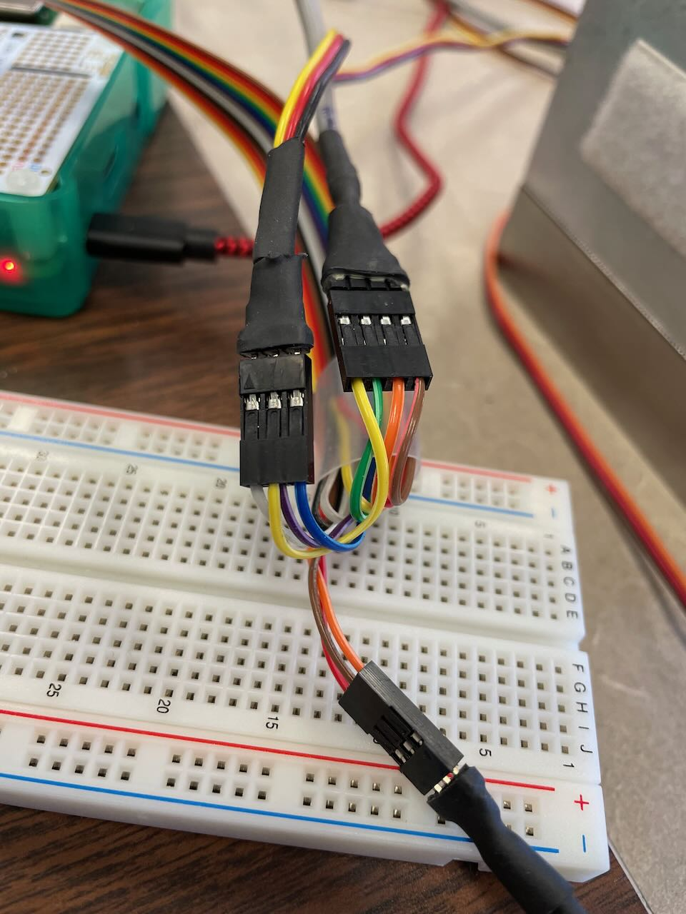

Figure The Dupont connectors for the 3 control cables connected to the ribbon cable.

Figure More details on the Dupont connectors, ribbon cable, and control cables.

#### USB to OpenScale

Connect a USB cable from the Raspberry Pi to the OpenScale board.

#### Ethernet to host PC

Connect an Ethernet cable from the Raspberry Pi to the host PC.

#### Power

When ready, connect a power supply capable of at least 2A to the Raspberry Pi’s micro USB port.

Note; it’s best to read section 2.2 before connecting the power.

### Sample Mount System

To enable fine control of the force exerted by the linear actuator during tensile testing, a simple mechanical spring-based system was developed. The springs provide enough “give” that the linear actuator can overcome internal friction and initiate incremental movement. It was found that a “stiff” system comprising two identical chucks limited the application of force to very large increments and was, thus, unsuitable.

The linear actuator end of the sample holder assemble is shown in Figure 15. The system comprises a 3D printed adapter that fits over the linear actuator shaft and contains a trapped bolt. The spring assembly comprises 2 fender washers with 4 holes evenly spaced on their periphery to accept springs, one per hole. One washer is connected to the adapter via the trapped bolt, while the other is attached to the threaded sample.

During initial testing it was observed that the original linear actuator design was flawed in that the 3D printer layers are perpendicular to the direction of applied force, which caused a catastrophic failure when the printed layers separated. An improved design was developed and is shown in Figure 16.

Figure Two views of the spring-based sample holder.

Figure An improved, stronger linear actuator adapter.

### Sample Mounting Procedure

The process for mounting a sample requires that the linear actuator be extended so that there is no tension on the springs and the right most fender washer in Figure 16 is close enough to the tail stock chuck.

The sample is assumed to have threaded ends (1/4” 20 tpi or similar) and nuts for both ends are available.

For the next steps, please refer to Figure 10 as needed.

Starting with the tail stock end, the sample should have a nut threaded on far enough to ensure a reasonable amount of contact; having the end of the sample flush with the nut as shown on the right in Figure 16 would be sufficient. The tail stock chuck jaws are opened wide enough so that the end of the sample with the nut can be inserted. The “shoulder” of the nut should extend past the inner shoulder of the jaws so that when they are tightened the nut will prevent the sample from pulling axially through the jaws. As the jaws are tightened, wiggle the sample a little to ensure that all 3 jaws contact the sample shaft evenly. Tighten the chuck as much as possible using only hand force; do not use a pipe wrench or other tool!

With the sample secure in the tail stock chuck, extend the linear actuator shaft far enough that the right (as seen in Figure 16) fender washer will slip over the free end of the sample. Slip the washer over the sample end, add a ¼” washer, and then thread on the matching nut so that the spring assembly and sample resemble Figure 16.

Now you are ready to apply tension.

Removing the sample is just the reverse of the steps above, except that if the sample is broken, the left end can be slid out.

## Operational Guidelines

### Power Up (Boot) Process

The Raspberry Pi (RPi) requires at least a 2A power supply for reliable operation.

The steps to power up the system are outlined in Figure 17.

First make sure that all electrical connections are correct and there is no sample mounted.

Connect the RPi to the host PC via an Ethernet cable.

The RPi should be powered on first to prevent uncontrolled motion of the test frame. To power on the RPi simply plug the USB micro power cable into the RPi and the other end into the wall brick. While the RPi boots up you should see a solid red light and a flashing green light on the board. Wait until the green light stops flashing, this indicates the RPi has finished the boot process.

Next plug the 24V power system into line power.

The system is now powered and ready to access. The power down sequence reverses the order as shown in Figure 17.

Figure The system startup and shutdown sequence.

### Network Configuration

#### Connecting to a Network

Now that the RPi has successfully powered on we need to access the web interface to control the machine. First the RPi must be connected to a network and a wired connection (Ethernet) is assumed.

#### SSH Access

If needed, for maintenance or to make software changes, the usual method is via ssh using the host PC. The RPi should have the named address “tensilepi.local” on the network. To connect to it, open a terminal (Command Prompt in Windows) and use the ssh command to connect;

ssh pi@tensilepi.local

The password is “t3ns1le”.

If the RPi cannot be reached, check in the terminal that it’s address is known by using the “ping” command, i.e., ping tensilepi.local. If the address is not known, you may need to use an address discovery tool like nmap.

For more details, see the “TensileTester RPi Setup.pdf” document.

### Browser Access

The user interface (UI) is accessed via a web browser on the host PC. To reach it, open a browser and enter the URL

<http://tensilepi.local:1800/ui>

An example of the initial user interface is shown in Figure 18.

Figure The initial user interface when the system is first started.

# Operating the Tensile Tester

In this section, the user interface-based operation of the Tensile Tester is described.

## Starting the User Interface

See section 2.2.3.

The user interface is accessed at the URL <http://tensilepi.local:1880/ui>

## User Interface Sections

Each section of the user interface is described in the subsections below. Some general practices or recommendations are made as appropriate.

### Data Logging Section

The Tensile Tester supports the manual and automatic application of tension. The latter is managed by the RPi using a PID control loop and ***is an experimental function***. The Data Logging section graph shows the actual (applied) tension the sample experiences plus, when automatic tension control is enabled, the PID loop tension target.

The Data Logging graph shows the applied and target tensions as rolling functions of time. In Figure 19 we see a) the initial display right after system start on the left and b) the result of applying tension manually on the right. The light blue trace is the applied tension the sample experiences as measured by the load cell.

Figure a) the initial display at startup, b) the manual application of tension with the applied tension shown in light blue.

When automatic tension control is enabled (see Section XXXXX), the RPi will attempt to set the applied tension to the desired target tension (as set in the Tension section, see section 3.2.2). The operation of the algorithm is observed through the tension variable that is plotted as a darker blue line on the graph. For example, see Figure 20 where automatic tensioning was enabled a little before the timestamp 58:43. The dark blue trace shows that 10 kg tension was applied by the linear actuator until the measured tension (light blue) was close to 10 kg when the applied tension was sharply reduced. Thereafter the control algorithm “dithered” the applied tension to reach a steady state for measured tension in the sample.

Figure The automatic tension control algorithm is enabled for 10 kg tension. The dark blue trace is the control algorithm’s applied tension.

### Tension Section

The Tension section, shown in Figure 21, displays the current sample tension reported by the OpenScale board and the target tension. The target tension is applicable when automatic tension control is selected (see section XXXX). There is a text entry box where sample tension can be entered. There is no bounds checking, so avoid entering negative numbers or any number greater than, say, 100, which is at least 5 times more than any experimental tension expected.

Figure The Tension section showing the current sample tension, the tension set point/target, and text entry box for the set point.

### Actuator Motion Section

This section, shown in Figure 22, has controls and settings that govern the applied tension. From top to bottom, the controls functions are

* Actuator On; This toggle slide will enable and disable the linear actuator motor.
  + If Manual Tension is selected when this turned on, the linear actuator will not move.
* If Automatic Tension is selected when this is turned on, the linear actuator will attempt to apply the target tension as set in the Tension section (see section 3.2.2)

***NOTE: This can be very dangerous to the operator and the sample and it is not recommended to enable Automatic Tension at this time.***

Figure The Actuator Motion section with the settings and controls that govern the applied tension.

* **Toggle Manual/Automatic control;** This toggle slide will enable Manual Tension or Automatic Tension mode. As shown in Figure 22,
  + when the button is positioned to the left, Manual Tension mode is enabled, and
  + when the button is positioned to the right, Automatic Tension mode is enabled.
* **Actuator Extend;** This large rectangle button is enabled when Manual Tension mode is enabled. Clicking it will run the linear actuator motor for a short burst according to the Actuator Speed setting.
  + Extending the linear actuator has the effect of reducing tension on the sample.
* **Actuator Retract;** This large rectangle button is enabled when Manual Tension mode is enabled. Clicking it will run the linear actuator motor for a short burst according to the Actuator Speed setting.
  + Retracting the linear actuator has the effect of increasing tension on the sample.
* **Actuator Speed;** This slider selects the incremental tension applied to the sample when Manual Tension mode is enabled. The range is [0,100] which is an arbitrary scale that is proportional to the tension applied.

In practice, there is a small amount of friction to overcome to start the linear actuator, so very small speeds will do nothing at all. The smallest increment we were able to induce was about 10 g.

#### Actuator Speed Setting Recommendations

It is ***strongly recommended to use low Actuator Speed at all times***. The only exception is either when there is no sample present, or the actuator is being extended to relieve tension, say at the end of an experiment.

Using high speeds can result in an almost step application of large force that may cause sample deformation or breakage.

### Rotation Section

The Rotation section, shown in Figure 23, shows the current rotation of the sample and has controls to rotate the sample in three different ways. The section comprises,

* **Current Angle;** This guage shows the current rotation angle. It updates after the sample rotation is complete (i.e., it’s not live). Zero (0) degrees is relative to the position of the rotary tables when the “Zero Rotation” button is clicked (see Section 3.2.5) or from the time the system is first started.
* **Change Rel(ative) Angle;** This text entry box can be used to set the angle relative to the current position. Entering a non-zero real number (i.e., ± decimal value) and clicking “MOVE” will cause the sample to rotate by that many degrees. The minimum angle possible is ±0.00625 degrees)
* **Set Absolute Angle;** This text entry box can be used to set the absolute angle with respect to the original zero (0) degrees position. Entering a non-zero real number (i.e., ± decimal value) and clicking “MOVE” will cause the sample to rotate to that rotational position. The resolution of the setting is 0.00625 degrees.
* **Move Steps;** This is a legacy function that takes the number of steps to move the stepper motors. The value is a whole number and it is strongly recommended to keep that number under 180 degree * 160 steps/degree = 28,800 steps.
  + We don’t want to make large rotations at the best of time, and certainly not multiple rotations, and
  + When the tester rotates, the linear actuator and load cell cables will tend to wrap around the actuator or sample, respectively.

Figure The Rotation section showing the current sample rotation and controls to rotate the sample.

### Zero Section

The Zero Section, shown in Figure 24, manages zeroing the load cell or the rotational position.

* The ZERO LOAD CELL button is used as part of the load cell initialization process described in Section XXXX.
* The Calibrate Load text entry is used to enter the weight in kilograms of the calibration weight being used during load cell calibration.
* The CALIBRATE button is used to enter the calibration weight.
* The ZERO ROTATION button is used to set the measured rotation to zero (0) degrees for the sample’s current rotational position.

Figure The Zero section where the load cell can be calibrated or the current rotational position set to zero degrees.

# Load Cell Calibration

Zeroing the load cell will set the current tension to be the zero point, this is useful for removing all the tension not passing through the sample from the measurements. The load cell is zeroed simply by clicking the “zero load cell button”. It is also important that the load cell is properly calibrated to ensure the readings are accurate. Calibration is a multi-step process:

1. First remove the load cell from the machine and place it on the table. It’s easiest to unplug the cable and screw off the load cell and re-plug the cable once it’s on the table

1. Wait 30+ minutes, this is done to mitigate load cell creep
2. Zero the load cell using web interface
3. Place known calibration weight on load cell

1. Wait 30+ minutes, this is done to mitigate load cell creep
2. Input calibration weight into web interface and press “calibrate” button Graphical user interface, text, application, chat or text message

   Description automatically generated

Calibration is finished when tension values begin to appear again

1. Remove calibration weight and test calibration with different known weight
2. Re-attach load cell to tensile test frame
3. Re-zero system as required after attaching chucks and sampleA picture containing dirty, miller

   Description automatically generated

Note: There are other settings on the OpenScale that can be changed such as report rate and averaging multiple readings. This would be done by plugging the USB cable into another computer using a serial terminal to configure the settings. More details can be found here: <https://learn.sparkfun.com/tutorials/openscale-applications-and-hookup-guide/all#configuration>

# General Operation

1. TODO; need to show motor and power connection, get photo.
2. The notion of a “zero position” is relative in a sense as the samples are generally symmetric and unmarked (not indexed). On the user interface (UI) a “zero position” can be established, but all movement is relative in terms of direction and the angle indices inscribed on the rotary tables. We assume that experimental procedures will establish the context and definition for positive and negative rotation. In other words, rotation direction is arbitrary.  
     
   Rotation accuracy and precision is not arbitrary and the units are indicated in the UI.